* RGB LED:-

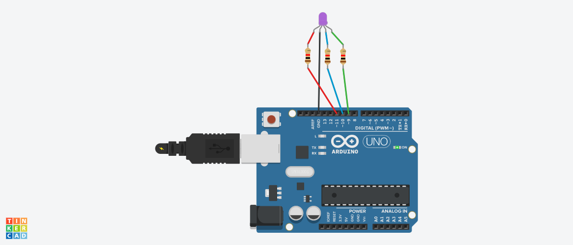

**Circuit diagram**

* **Description :-**

In this practical, we will learn about Arduino RGB led interfacing. The RGB led consists of three different LED’s; from the name you can guess that these LED’s are red, green and blue. We can obtain many other colours by mixing up these colours. The Arduino has an analog write function which will help us in obtaining different colours for Arduino RGB led.

* **Application :-** 
  + - * + Traffic signal.
        + In outdoor decoration lighting.
        + LED matrix display.
* **Working Principle:-**

RGB LED is a combination of three LEDs in just one package: red, green and blue; there are two kinds of RGB LEDs: common cathode and common anode RGB LEDs; **you generate different colors by adjusting the brightness of each of the three LEDs of the RGB LED**; to adjust the brightness of each LED, you use a PWM signal.

* .**Circuit Connection :-**

Connect the cathode of the RGB led which is the longer pin of RGB led to the GND of Arduino and the other three digital pins to the pin 11, 10, 9 of Arduino through the resistors. The resistors will prevent the excess amount of current to flow through the RGB led.

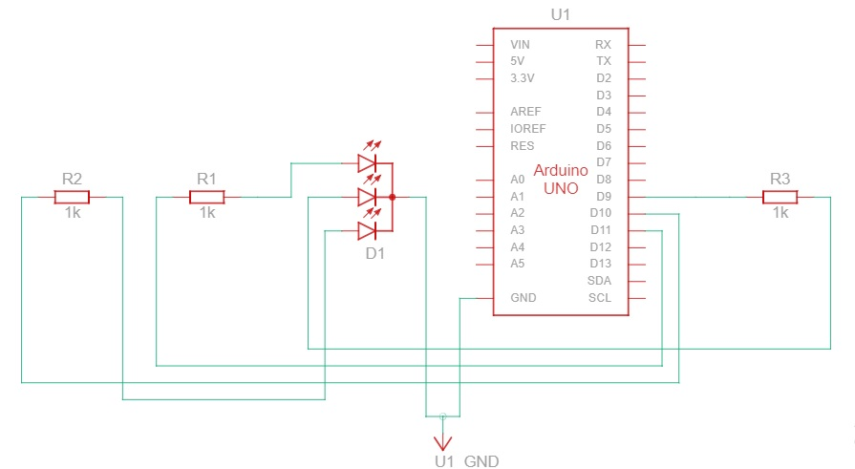

* Component List :-

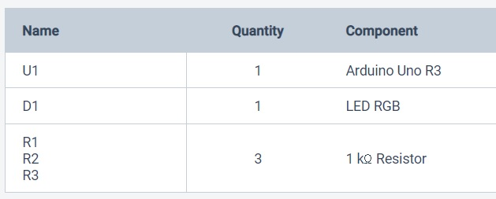

* **CODES :-**

// C++ code

//

void setup()

{

pinMode(11, OUTPUT);

pinMode(10, OUTPUT);

pinMode(9, OUTPUT);

}

void loop()

{

analogWrite(11, 255);

analogWrite(10, 0);

analogWrite(9, 0);

delay(1000); // Wait for 1000 millisecond(s)

analogWrite(11, 51);

analogWrite(10, 51);

analogWrite(9, 255);

delay(1000); // Wait for 1000 millisecond(s)

analogWrite(11, 51);

analogWrite(10, 204);

analogWrite(9, 0);

delay(1000); // Wait for 1000 millisecond(s)

}

* **BLOCKCODES :-**

